Research Design II – Literature Review and Research Methodology

This study aims to critically examine the research methodology used in teaching programming using virtual reality (VR) and consider the methodology selected for a particular study that is examining the effectiveness of VR versus conventional methods.

# Review of Research Methodology

The majority of VR application studies in programming instruction utilize quasi-experimental designs. As indicated in the study by Theethum et al. [1], who created the educational VR game Thinkercise, such studies normally utilize pre- and post-testing to quantify outcomes. In extending from this by including immersive self-avatar experiences and exploring computational thinking gains for middle school students, Parmar et al. [2] added to this. While Lopez-Fernandez et al. [4] employed a mixed-method approach that combined quantitative tests with qualitative semi-structured interviews to measure motivational impacts in game-based learning environments, Bicalho et al. [3] did a systematic review of the more general impact of VR on education.

Academic and non-academic material must be separated from one another. Academic literature, including conference proceedings and peer-reviewed journal publications, report outcomes that have been rigorously evaluated (e.g., research papers published in IEEE journals) [6]. Non-academic sources, including prototype feedback reports and informal interviews, report useful information but are not peerreviewed, thus are to be used cautiously [7].

The following five peer-reviewed articles are suggested to support this study: (1) Thinkercise by Theethum et al. [1], (2) VR Self-Avatar study by Parmar et al. [2], (3) Game-Based Learning study by Lopez-Fernandez et al. [4], (4) Immersive VR Educational Practices by Bicalho et al. [3], and (5) Gamification for intrinsic motivation by Luarn et al. [5].

VR has been referred to in the literature as a revolutionary tool for transcending the conventional education challenges. The traditional lecture format cannot match the interactive, embodied learning experience of virtual reality. While Theethum et al. [1] and Parmar et al. [2] documented knowledge and participation increases, Lopez-Fernandez et al. [4] observed an increase in motivation, but that knowledge acquisition may not differ significantly between the traditional learning method and gamebased learning methods. As far as the issues of scalability and long-term retention of the programming knowledge acquired via VR interventions go, there is still an important gap.

Since numerous studies are backing each of the concepts, a map of literature connecting VR in computer programming education is able to represent the interconnection between motivation, interest, and knowledge retention and how all the relationships are clear and properly labelled.

# Literature Map

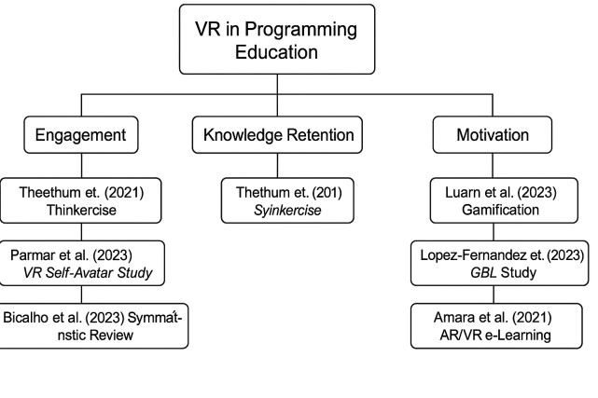

# Reflection of Chosen Methodology

The primary research questions of this study are: (1) How does virtual reality influence students' engagement as compared to conventional methods? (2) How does virtual reality impact the comprehension and application of programming concepts? (3) Does virtual reality help people recall programming concepts eventually?

The aims are to create an educational model of VR that can be applied to the students' learning requirements, compare their learning and retention levels through pre- and post-testing, and gain qualitative evidence from behaviour observation and semi-structured interviews. Choosing methodology was limited by an initial awareness of research paradigms and philosophies. The research is practical and honours both objective and subjective understanding [8]. It is favourably disposed to positivist paradigms of analysis of measurable outcomes and interpretivist paradigms for illuminating human understanding.

A quasi-experimental design with mixed approaches was adopted. For the measurement of notable change, quantitative components review pre- and post-test measurement through paired samples ttests [9]. Semi-structured interviews and observation are some of the qualitative aspects that provide greater insight into the experiences and likes of the users. In experimental design, one group of students will be initially taught in the conventional manner through PowerPoint presentations and will be given a pre-test. They will then be given a VR lesson, with the VR game questions incorporated into the posttest. To guarantee consistency, pre- and post-tests are administered to both groups. Additional qualitative data are gathered from follow-up interviews and session observation. Statistical and thematic analysis techniques will be utilized to examine the data.

Use of tests, interviews, and observation augments the validity of this research. Having assessed the VR prototype before applying it ensures technical problems can be highlighted and addressed, thus increasing reliability. However, the small sample size and certain context of Level 3 program students limit generalisability.

Gaining informed consent, protecting participant anonymity by using random user IDs, offering withdrawal, and keeping VR sessions short (ten minutes) to prevent physical discomfort are all ethical concerns. Additionally, participant feedback will be integrated to enhance the usability and accessibility of the VR application.

# Reference List

1. T. Theethum, A. Arpornrat and S. Vittayakorn, "Thinkercise: An educational VR game for Python programming," 2021 18th International Conference on Electrical Engineering/Electronics, Computer, Telecommunications, and Information Technology (ECTI-CON), Chiang Mai, Thailand, 2021, pp. 439442, doi: 10.1109/ECTI-CON51831.2021.9454730.
2. D. Parmar, L. Lin, N. D'Souza, S. Jörg, A. E. Leonard, S. B. Daily, and S. V. Babu, "How Immersion and Self-Avatars in VR Affect Learning Programming and Computational Thinking in Middle School Education," IEEE Transactions on Visualization and Computer Graphics, vol. 29, no. 8, pp. 3698-3710, Aug. 2023, doi: 10.1109/TVCG.2022.3169426.
3. D. R. Bicalho, J. M. N. Piedade and J. F. de Lacerda Matos, "The Use of Immersive Virtual Reality in

Educational Practices in Higher Education: A Systematic Review," 2023 International Symposium on

Computers in Education (SIIE), Setúbal, Portugal, 2023, pp. 1-5, doi:

10.1109/SIIE59826.2023.10423711.

1. D. López-Fernández, A. Gordillo, J. Pérez, and E. Tovar, "Learning and Motivational Impact of GameBased Learning: Comparing Face-to-Face and Online Formats on Computer Science Education," IEEE Transactions on Education, vol. 66, no. 4, pp. 360-368, Aug. 2023, doi: 10.1109/TE.2023.3241099.
2. P. Luarn, C.-C. Chen, and Y.-P. Chiu, "Enhancing intrinsic learning motivation through gamification: a self-determination theory perspective," International Journal of Information and Learning Technology, vol. 40, no. 5, pp. 413–4424, 2023, doi: 10.1108/IJILT-07-2022-0145.
3. L. Cohen, L. Manion, and K. Morrison, Research Methods in Education, 6th ed., London: Routledge, 2007.
4. S. Kvale and S. Brinkmann, InterViews: Learning the Craft of Qualitative Research Interviewing, SAGE Publications, 2009.
5. W. C. Booth, G. G. Colomb, J. M. Williams, J. Bizup, and W. T. FitzGerald, The Craft of Research, 4th ed., Chicago: University of Chicago Press, 2016.
6. "The Paired Samples T Test," Kent State University Libraries. [Online]. Available: [https://libguides.library.kent.edu/spss/pairedsamplesttest.](https://libguides.library.kent.edu/spss/pairedsamplesttest)